**AHSAN HAMZA**

### A hospitality and consultancy professional with a keen interest in the Rooms Division and Events departments. Growing up in an international environment, I learned to adapt quickly to various challenges, and am confident that this will serve beneficial in my pursuit for new opportunities and growth in diverse work cultures.

**CONTACT**

[ahsanhamza545@gmail.com](mailto:ahsanhamza545@gmail.com)

+971 55 102 5787

### Ahsan Hamza

Dubai, United Arab Emirates

**SKILLS**

Microsoft 365 - ICDL Certified in Excel Proficient in:

Adaco SurfSonic SevenRooms Opera/MICROS TravelClick Oasys Live

Data analysis

Financial valuations & account management Ability to work in short deadlines

Strong written & verbal communication skills Efficient problem solving skills

# LANGUAGES

English Hindi Urdu Arabic

# EXPERIENCE

## FIVE Life & Food and Beverage Sales Coordinator

### FIVE Hotels & Resorts, Dubai, UAE | January 2020 - Present

Data management across various platforms such as TravelClick, SurfSonic, Opera, SevenRooms Statistical analysis of various data sets

Promoting venues across various internal and external platforms Handling group reservations for venues and special events in the hotel

Business development and strategy planning for venues and special events

## Entertainment Coordinator

### FIVE Hotels & Resorts, Dubai, UAE | July 2019 - Present

Listed as a promoter for The Penthouse

Provide logistical and operational support across venues in FIVE Hotels & Resorts. Handle contracts and logistical advances between the hotel and third parties Provide concept development models for venues

Enhance operational efficiency and effectiveness through identifying opportunities, strengths, and weaknesses

Manage relations with renowned artist agencies

Artist and performance coordinator for LUVYA Music Festival Ensure all artists have legal permits across venues to perform

Artist and performer acquisition across all venues in FIVE Hotels & Resorts

## Part-Time Experience (2015-2018)

Waiter, *Madinat Jumeirah, Dubai, UAE |* September 2015 - July 2016 Assisted with service operations in catering events

Events Team, *Ghaf Kitchen, Dubai, UAE |* June 2017

Assisted with service operations as well as creating and setting up seating plans for the month of Ramadan at Café Rider

Freelance Promoter, *MMZ Sports, Dubai, UAE |* December 2017 - March 2018

Supervised ADIB activation events organized by MMZ Sports during the Arabian Gulf League

## Sales and Marketing Intern

### Radisson Hitec City, Hyderabad, India (August 2016- January 2017)

6-month internship that included a 2-month rotation in Front Office Operations Pre-opening team for Chama Gaucha, the first churascaria in Hyderabad, India Promoting F&B sales and marketing venues, and concept development for events

# INTERESTS

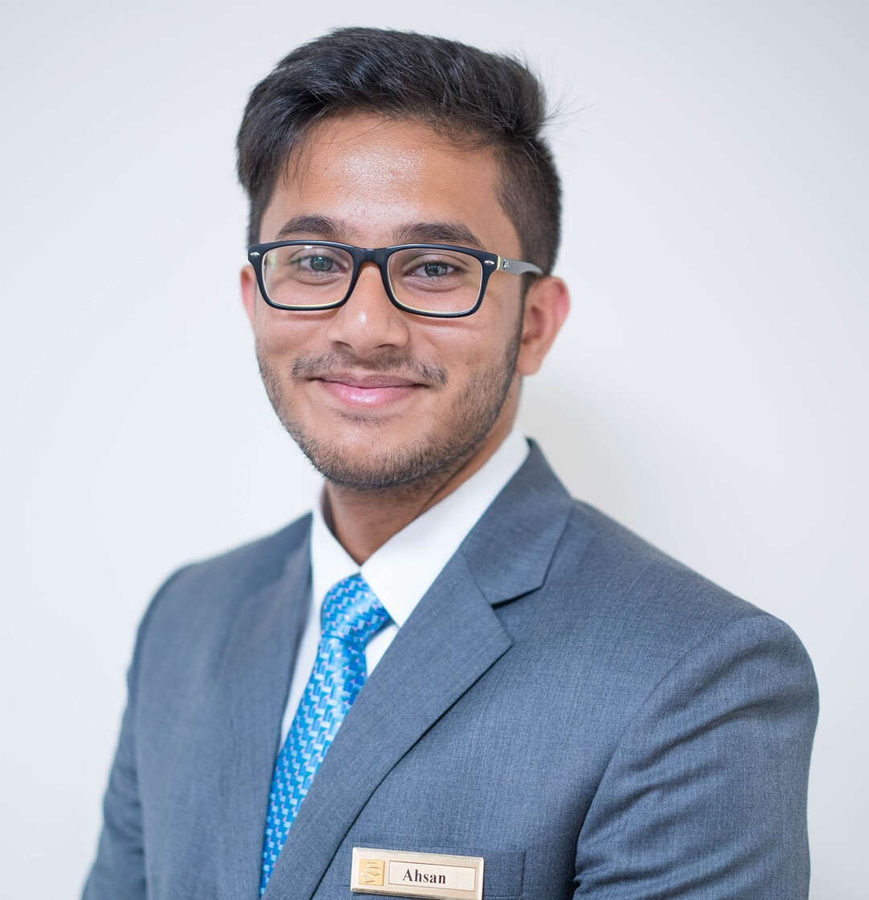

**EDUCATION**

## BBA (Hons.) International Hospitality Management, 2018

### The Emirates Academy of Hospitality

Management (Dubai, UAE)

**High School Diploma, 2015**

Indian Educational School (City, Kuwait)

**VOLUNTEER**

**Vipers Football (2011-2013)**

Vipers F.C. Tournaments (Rigga, Kuwait)

Founder / Organizer of tournaments

**Student Council (2015-2018)** The Emirates Academy of Hospitality Management (Dubai, UAE)

Head of Events (2016-2017) Vice President (2017-2018)

President (2018)